Stephanie Corcoran, Ph.D. NCSP

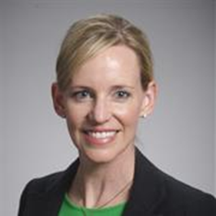
Stephanie Corcoran is a nationally certified school psychologist and faculty at the University of Alabama at Birmingham (UAB) where she directs the school psychometry/psychology program. She maintains an active research program that studies psychoeducational assessment and school-based interventions. Dr. Corcoran has written scholarly articles, book chapters, and a children’s book. She has been invited to deliver numerous presentations at state, national, and international conferences.She is the current President of the Alabama Association of School Psychologists.

